**10 Bit Stuffing Program:**

#include <stdio.h>

#include <string.h>

int main() {

char data[100], stuffedData[200];

int i, count = 0, j = 0;

printf("Enter the data: ");

scanf("%s", data);

for(i = 0; i < strlen(data); i++) {

if(data[i] == '1') {

count++;

stuffedData[j++] = data[i];

} else {

count = 0;

stuffedData[j++] = data[i];

}

if(count == 5) {

count = 0;

stuffedData[j++] = '0';

}

}

stuffedData[j] = '\0';

printf("Data after bit stuffing: %s\n", stuffedData);

return 0;

}

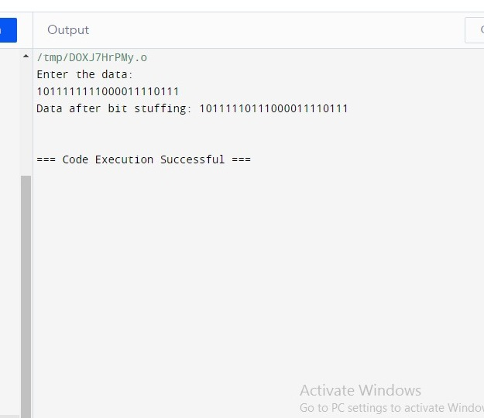

**Program 11 LRC :**

#include <stdio.h>

// Function to calculate LRC

unsigned char calculateLRC(unsigned char *data, int length) {

unsigned char lrc = 0;

for (int i = 0; i < length; i++) {

lrc += data[i];

}

// Take the one's complement of the sum

lrc = (~lrc) + 1;

return lrc;

}

// Function to print a byte in binary format

void printBinary(unsigned char byte) {

for (int i = 7; i >= 0; i--) {

printf("%d", (byte >> i) & 1);

}

}

int main() {

// Example data to be sent (replace this with your actual data)

unsigned char dataToSend[] = {0x41, 0x42, 0x43, 0x44}; // "ABCD" in ASCII

int dataLength = sizeof(dataToSend) / sizeof(dataToSend[0]);

// Calculate LRC for the data

unsigned char lrc = calculateLRC(dataToSend, dataLength);

// Append LRC to the data

dataToSend[dataLength] = lrc;

// Display the data with appended LRC in binary format

printf("Data with appended LRC (in binary):\n");

for (int i = 0; i < dataLength + 1; i++) {

printBinary(dataToSend[i]);

printf(" ");

}

printf("\n");

return 0;

}